NIH Evaluation Set-Aside Program
User Guide for Creating and Submitting
LETTER OF INTENT

Starting in FY 2015, all letters of intent (LOIs) for requesting NIH Evaluation Set-Aside funding to conduct a program evaluation or to develop program performance measures must be submitted online using the Evaluation Set-Aside (ESA) System at http://esa.od.nih.gov. The following guidance will assist you in creating and submitting your LOI.
If you have any questions or require assistance, please email the DPCPSI Office of Program Evaluation and Performance (OPEP) at Evaluate@mail.nih.gov. To report a problem with the ESA System, please include the following information in your email: (1) the date and time the problem occurred, (2) the browser you used, (3) a description of the problem you encountered, and (4) when applicable, screenshot(s) related to the problem.

FY 2015 LOI Submission Due Date: November 19, 2014

Contents:

Before You Start | Page | 2
How to Access ESA System | Page | 2
How to Create and Save LOI | Page | 4
Section 1 – Project Title and Contact Information | Page | 5
Section 2 – Type of Proposed Project | Page | 11
Section 3 – Estimated Cost of Proposed Project | Page | 12
Section 4 – Program Summary and Project Overview | Page | 13
How to Edit LOI | Page | 15
How to Submit LOI | Page | 17
How to View Submitted LOI | Page | 18
How to Revise LOI to Address Issues Identified by OPEP | Page | 20
Appendix: Information Needed to Prepare Letter of Intent | Page | 23

Before You Start

- Note the LOI submission due date. You may want to set a reminder on your calendar.
- Notify your P&E officer that you plan to submit an LOI. Develop a timeline with your P&E officer that will give you sufficient time to draft your LOI, obtain your P&E officer’s clearance, and create and submit your LOI online. (Contact Evaluate@mail.nih.gov if you are not sure who serves as your P&E officer.)
- Prepare your LOI using Microsoft Word. See the appendix (pages 23-24) for guidance.
- Make sure Google Chrome or Internet Explorer 10 is installed on your computer. Contact your IT HelpDesk, if needed.
- Log in to http://esa.od.nih.gov once to make sure you can access the ESA System successfully (see How to Access ESA System below).

How to Access ESA System

- If Google Chrome or Internet Explorer 10 is your computer’s default browser, hold down “Ctrl” on your keyboard and click this link: http://esa.od.nih.gov.
If your computer has a different default browser, you must manually open Google Chrome or Internet Explorer 10 on your computer. Type “http://esa.od.nih.gov” in the address bar, and press “Enter” on your keyboard.

TIPS
- Internet Explorer 10 users may see a “BROWSER NOT SUPPORTED” message. Ignore this message and click “OK” to proceed with login.
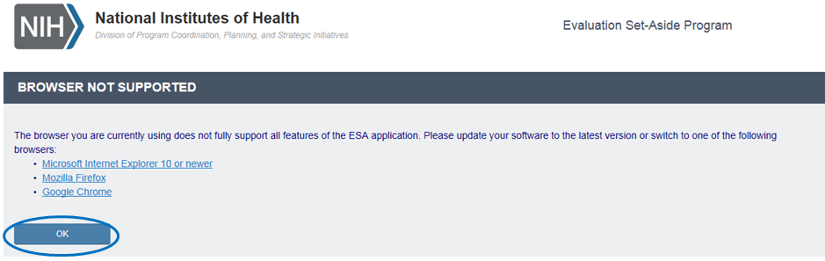
  - Internet Explorer 8 does not fully support the features of the ESA System. Checkboxes and certain fields do not work properly. You will not be able to complete and submit your LOI in this browser.
  - The ESA System is compatible with Mozilla Firefox, but some testers have reported problems with NIH’s single sign-on when using this browser to access the ESA System. Logging in with your username and password sometimes generates an error message. In order to use your PIV card and PIN, Mozilla Firefox must be configured to enable HHS ID badge access.
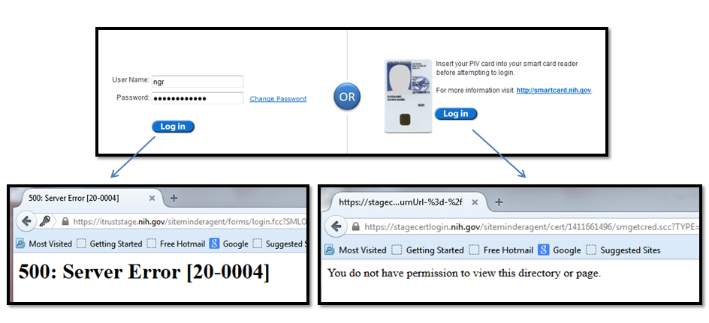
- When the NIH log-in screen is displayed, log in using your username and password or your PIV card and PIN.
- When you see your homepage – notice your name on the upper right corner – you have successfully logged in to the ESA System.
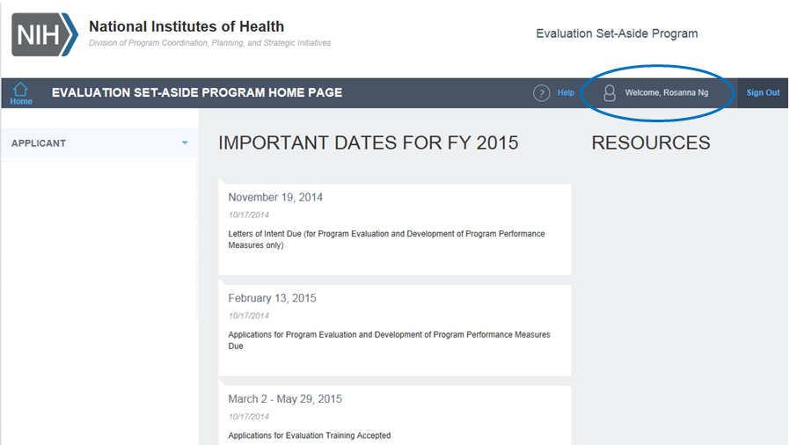

How to Create and Save LOI

- On your homepage, click “APPLICANT” in the left panel to open the menu.
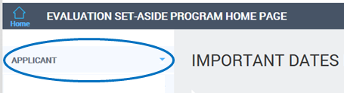

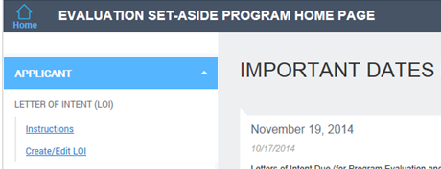
- Click on the “Create/Edit LOI” link to access the LOI form.
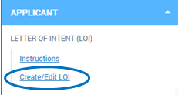

- The LOI form has 4 sections. Use the scroll bar to move from section to section.
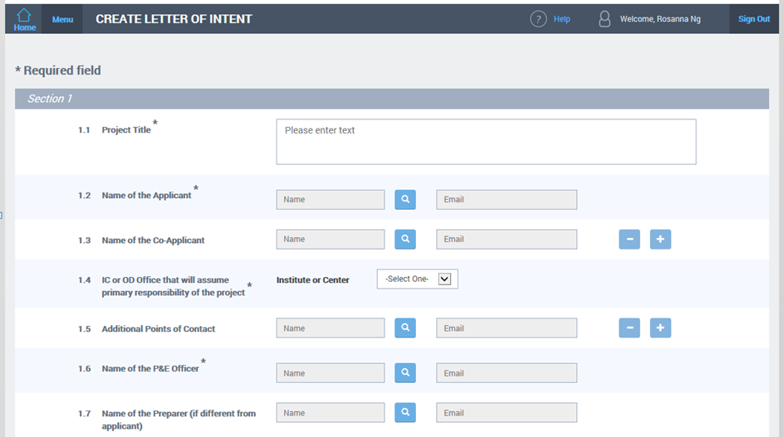
TIPS
- To submit your LOI, all required fields – denoted by asterisks – must be completed. To save your LOI as a draft, only the first two items (1.1 and 1.2) need to be filled.

- Saving your LOI as a draft will help you avoid losing what you have entered, should your browser session time out. Also, the auto-save feature is activated when you return to work on your draft.
Note: When you click on the “Save as Draft” button, you will exit the LOI form and return to your homepage. See How to Edit LOI (pages 15-16) for instructions on how to access your draft LOI.

- Section 1 – Project Title and Contact Information
- Item 1.1: Enter the title of the proposed project.

- Item 1.2: Only one applicant may be included. The individual must be a federal employee.
To enter the name and email address of the applicant, click on the “Search” icon, which looks like a magnifying glass, to activate NED look-up.
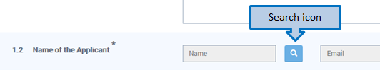
When the search window opens, type in the first and last names of the applicant, and click “Search”.
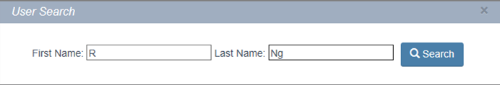

When the search results are shown, select the appropriate name from the list. The selected name and associated email address are automatically added to the relevant fields in the LOI form.
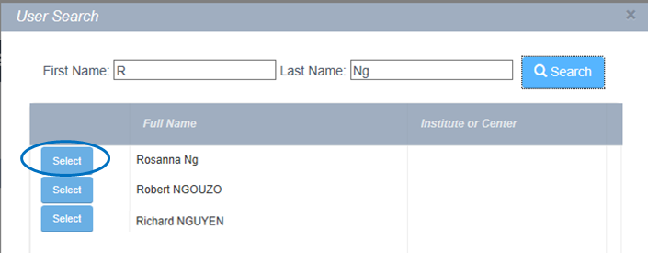
⬇
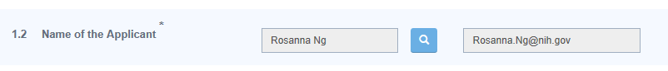
TIPS
  - The speed of NED look-up service is not within OPEP’s or the ESA System’s control. Loading time is affected by many factors.
  - When using NED look-up, you can type in just the first few letters of the first and last names instead of the full name. However, the search will take longer and may yield a longer list of results.
  - It will be possible to change the applicant information during the application phase.
- Item 1.3: If applicable, one or more co-applicants may be included. Note: Co-applicants have the ability to modify the LOI before it is submitted. Also, they will be copied on all correspondence related to the LOI.
To enter the name and email address of a co-applicant, follow the steps as described in Item 1.2 (pages 5-6).
To enter the name and email address of an additional co-applicant, click on the “Plus” (+) button to the right.
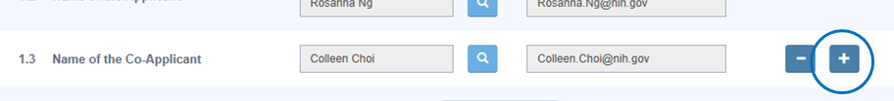
When the search window opens, type in the first name and last name of the additional co-applicant, and click “Search”. When the search results are shown, select the appropriate name from the list. The selected name and associated email address are automatically added to the second row.
To remove a co-applicant, click on the “Minus” (-) button for the row that you want to delete.
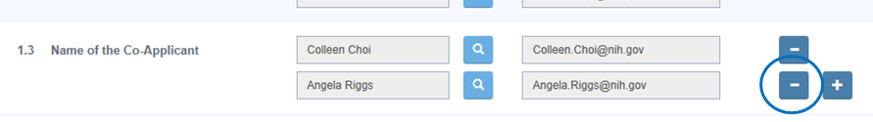
- Item 1.4: Open the drop-down menu to select the IC that will assume primary responsibility of the proposed project.
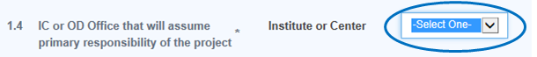
If an OD office will assume primary responsibility, select “OD” from the drop-down menu. When the additional “OD Office” drop-down menu appears, select the appropriate OD office (e.g., DPCPSI). In addition, you have the option of entering the acronym of the sub-office (e.g., OPEP).
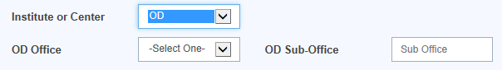

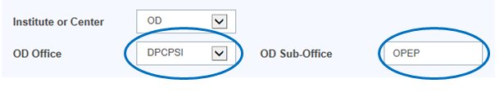
TIPS
  - Do not try to enter the full name of the sub-office – the field has a 10-character limit.

- Item 1.5: If applicable, one or more additional points of contact (e.g., a colleague or P&E staff member who worked with the applicant on the LOI) may be included. Note: Additional contacts have the ability to modify the LOI before it is submitted. Also, they will be copied on all correspondence related to the LOI.
To enter the name and email address of an additional contact, follow the steps as described in Item 1.2 (page 5-6).
To enter the name and email address of a second additional contact, follow the steps as described in Item 1.3 (pages 6-7).
- Item 1.6: You must include the P&E officer who reviewed and cleared your LOI for submission. To enter the name and email address of your P&E officer, follow the steps as described in Item 1.2 (pages 5-6).
- Item 1.7: If the LOI is being created by someone other than the applicant, identify the preparer. Note: The preparer has the ability to modify the LOI before it is submitted. Also, he/she will be copied on all correspondence related to the LOI. It is unnecessary to list him/her under Item 1.5.
To enter the name and email address of the preparer, follow the steps as described in Item 1.2 (pages 5-6).

- Item 1.8: If applicable, identify any internal or external co-sponsor who has agreed to provide financial and/or in-kind support for the proposed project. Note: You may include internal as well as external co-sponsors. Co-sponsors will not have the ability to modify the LOI before it is submitted. Also, they will not be copied on any correspondence related to the LOI.
If a co-sponsor is within NIH, check the “Within NIH” box to reveal the required fields for internal co-sponsor.
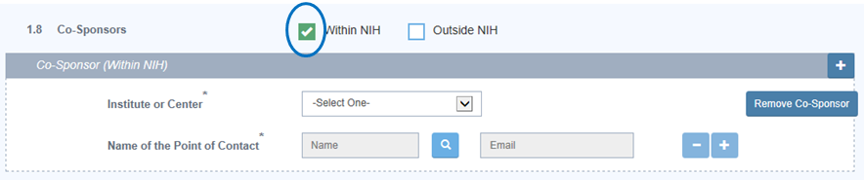

If an IC is a co-sponsor, open the drop-down menu to select the IC. To enter the name and email address of your primary contact within the selected IC, follow the steps as described in Item 1.2 (pages 5-6).
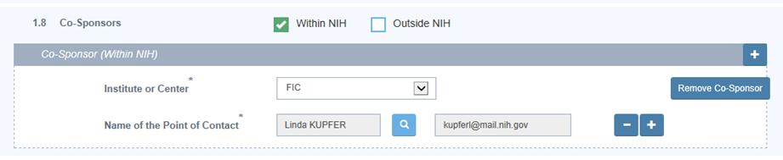

If an OD office is a co-sponsor, select “OD” from the drop-down menu. When the additional “OD Office” drop-down menu appears, select the appropriate OD office. If applicable, enter the acronym of the sub-office.
To enter the name and email address of your primary contact within the selected OD office, follow the steps as described in Item 1.2 (pages 5-6).
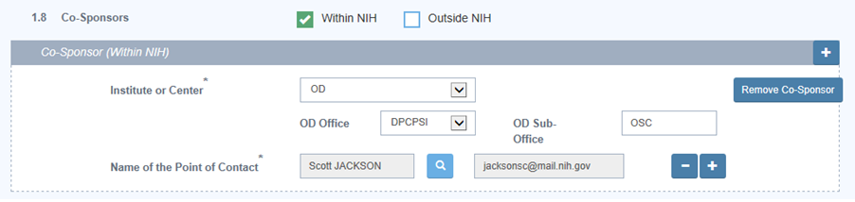
To add another internal co-sponsor, click on the “Plus” (+) button at the end of the “Co-Sponsor (Within NIH)” bar, and complete the required fields for the new row.
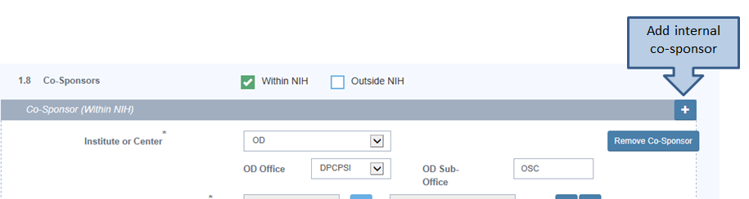

To remove an internal co-sponsor, click on the “Remove Co-Sponsor” button for the row you want to delete.
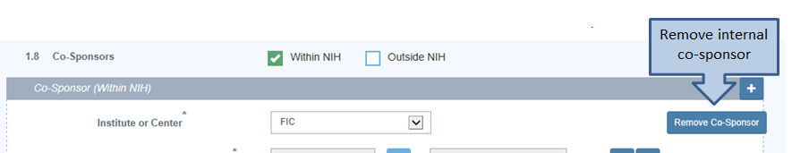
If a co-sponsor is outside of NIH, check the “Outside NIH” box to reveal the required fields for external co-sponsor.
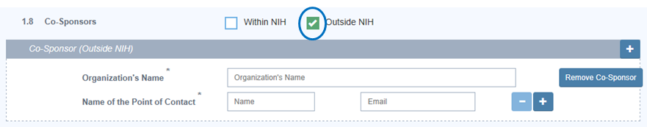
Enter the name of the organization, as well as the name and email address of your primary contact within the organization.
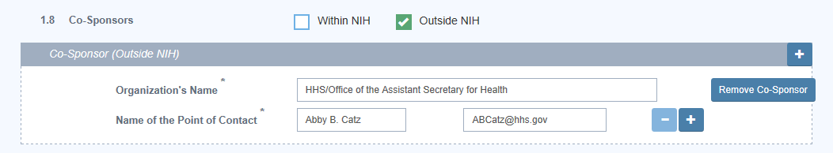
To add another external co-sponsor, click on the “Plus” (+) button at the end of the “Co-Sponsor (Outside NIH)” bar and complete the required fields for the new row.
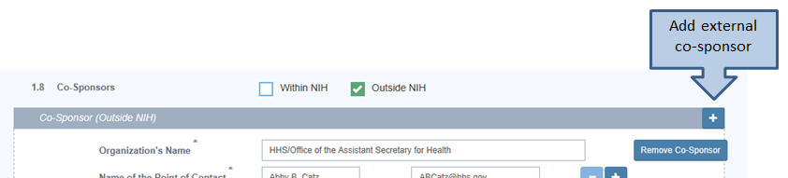

To remove an external co-sponsor, click on the “Remove Co-Sponsor” button for the row you want to delete.
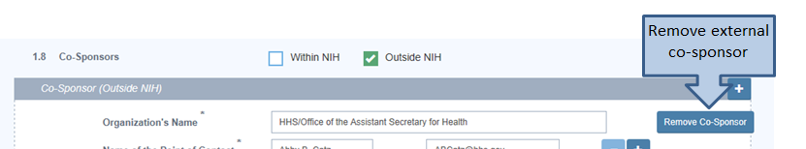

- Section 2 – Type of Proposed Project

- Item 2.1: Select the appropriate radio button to indicate whether the proposed project is for evaluating a program or developing program performance measures. An example is shown below.
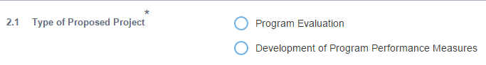

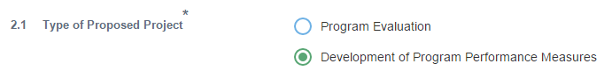
- Item 2.2: If “Program Evaluation” is selected, you must indicate the type of evaluation planned by checking the appropriate box(es).
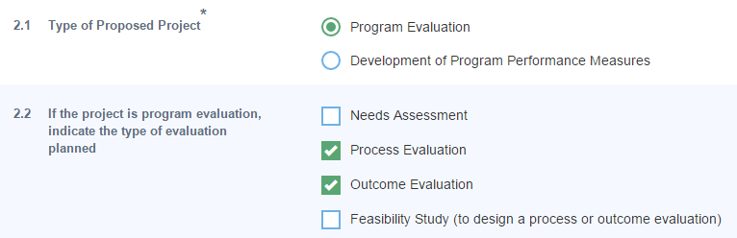
TIPS
  - Item 2.2 does not appear when “Development of Program Performance Measures” is selected for Item 2.1.

- Section 3 – Estimated Cost of Proposed Project

- Item 3.1: Enter the estimated cost of the proposed project.
You have the option of entering a range ...
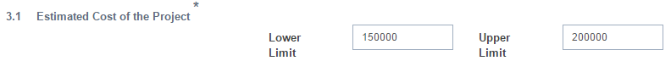

… or entering the same value for both lower and upper limits.
TIPS
  - There is no need to enter dollar signs or commas.
  - The fields can accept up to two decimal points, but please use whole numbers.
  - Reminder: The estimated project cost to develop program performance measures may not exceed $100,000.

- Item 3.2: Enter a brief description of how ESA funds will be used to support the proposed project. Note: ESA funds may not be used to develop or implement program activities, including those that stem from findings or recommendations of the proposed project.
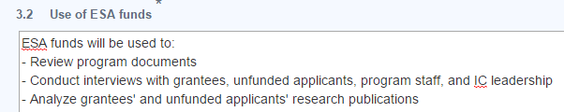
TIPS
  - If you copy text from a MS Word document and paste it to the LOI form, formatting (bullet points, separation of paragraphs, etc.) may not be retained. Preview your draft LOI by clicking “Print Draft LOI”. Edit text field as needed.


- Section 4 – Program Summary and Project Overview

- This section, made up of three parts, may not exceed 10,000 characters. A counter is displayed at the top and bottom of this section to help you keep track of the characters remaining.
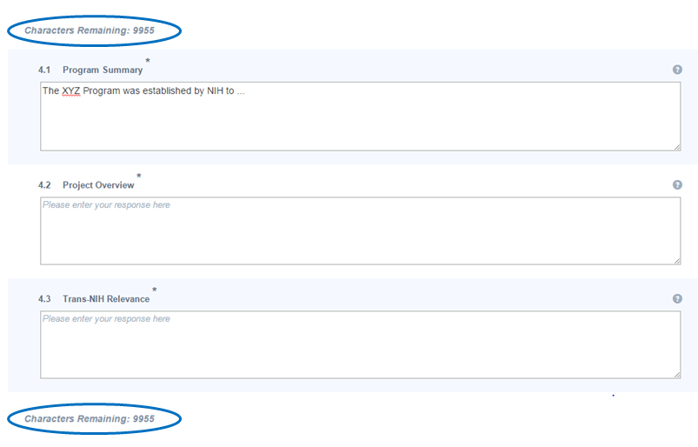
- Item 4.1: Enter a concise description about the program to be evaluated or for which performance measures will be developed.
- Item 4.2: Enter a concise description of the purpose and scope of the proposed project.
- Item 4.3: Enter a brief discussion of how the proposed project and its findings or products may benefit other ICs or NIH at large.

TIPS
  - If you copy text from a MS Word document and paste it to the LOI form, formatting (bullet points, separation of paragraphs, etc.) may not be retained. Preview your draft LOI by clicking “Print Draft LOI”. Adjust text fields as needed.

- To save your draft LOI, click on the “Save as Draft” button. After your draft is saved, you will exit the LOI form and return to your homepage.

TIPS
- Do not panic if you accidentally click on the “Reset LOI” button – select “Cancel” when a window appears with the question “Do you want to reset the Letter of Intent?”
- If you accidentally click on the “Submit” button, select “Cancel” when a window appears with the question “Are you sure you want to submit the Letter of Intent?”

- From your home page, if you want to create another LOI, click “APPLICANT” in the left panel.
When the menu opens, click on the “Create/Edit LOI” link.

When the new page is displayed, you will see a listing of the draft LOI you have saved. To create a new LOI, click on the “Create LOI” button to open a new form. Fill in the desired fields and save the new draft as described on pages 5-14.
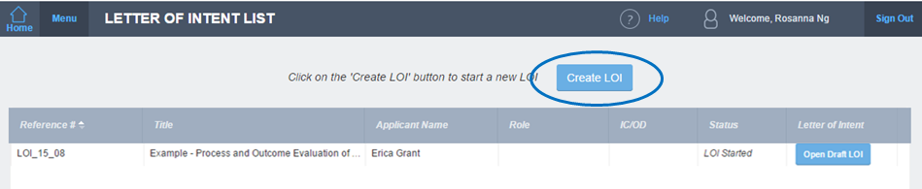

- When you are done, exit the ESA System by clicking “Sign Out” on your homepage.


How to Edit LOI

- Log in to http://esa.od.nih.gov to access the ESA System (see How to Access ESA System on pages 2-3).
- When your home page is displayed, click “APPLICANT” in the left panel.
- When the menu opens, click on the “Create/Edit LOI” link to see your list of draft LOI(s).
- When your list of draft LOI(s) is displayed, look for the LOI you want to edit, and click “Open Draft LOI” for the desired row.
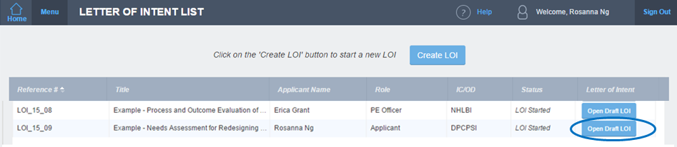

TIPS
- Your list may include draft LOI(s) that you did not create. The information under “Role” indicates why you are able to view and edit other draft LOI(s) – for example, you have been included as a P&E Officer, Co-Applicant, or Additional Point of Contact for a draft LOI created by another user.
- If multiple individuals (applicant, co-applicant(s), additional point(s) of contact, and/or preparer) are involved in the review and/or editing of a LOI, please coordinate to ensure there is clarity about each individual’s role (i.e., who will do what and when).
- If you accidentally open the wrong LOI, just click the browser’s “Back” arrow () to return to your list.
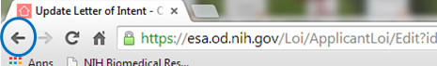

- When your draft LOI opens, edit the desired fields.
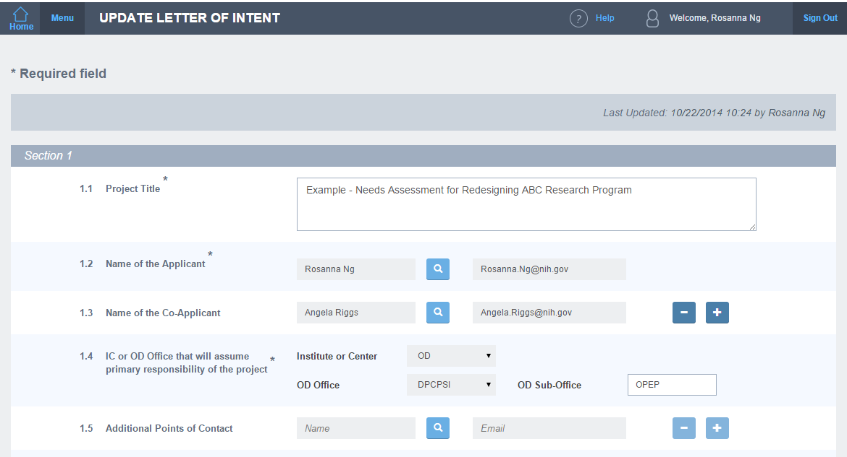
TIPS
  - If you need to make substantial changes to every section of the draft LOI, clicking “Reset LOI” will clear the entire form and allow you to start over.
- To review your edits and see how the LOI will appear to reviewers, click “Print Draft LOI” to download a PDF copy.
- Click “Save as Draft” to save your edits, exit the LOI form, and return to your homepage.

How to Submit LOI

- To submit your LOI, all required fields – denoted by asterisks – must be completed.
- If you try to submit an LOI with one or more required fields incomplete, a message will appear in the upper left corner to inform you that your attempt was unsuccessful and which required field(s) must be filled in. An example is shown below.


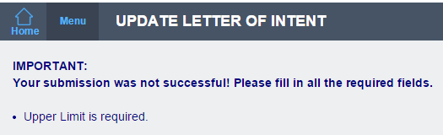
- When your LOI is complete and ready for submission, click on the “Submit” button.
- Select “Continue” when a new window appears with the question “Are you sure you want to submit the Letter of Intent?”
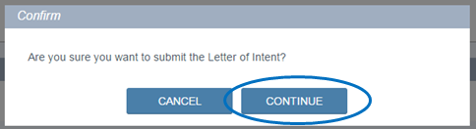

- When your submission has been successfully processed, a confirmation page will appear. You will also receive a submission confirmation via email with a PDF copy of your LOI attached.
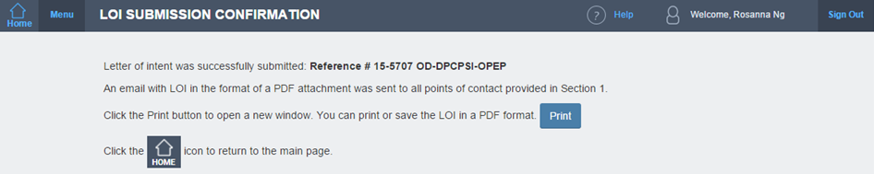

TIPS
- Once your LOI has been submitted, you will not be able to make any changes. If you realize something is amiss with your LOI after submitting it, contact Evaluate@mail.nih.gov about withdrawing your LOI, then create and submit a new LOI before the submission due date.

- Return to your homepage by clicking on the “Home” icon, or exit the ESA System by clicking “Sign Out”.

How to View Submitted LOI

- Log in to http://esa.od.nih.gov to access the ESA System (see How to Access ESA System on pages 2-3).
- When your home page is displayed, click “APPLICANT” in the left panel.
- When the menu opens, click on the “View LOI” link.
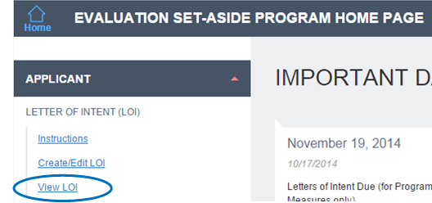
- When your list of submitted LOI(s) is displayed, click the ESA reference number for the LOI you want to view.
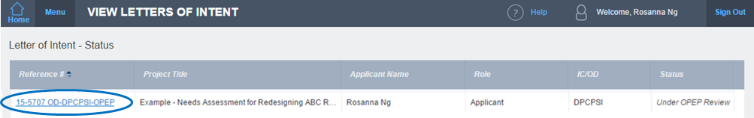

TIPS
- Your list may include LOI(s) that you did not create or submit. The information under “Role” indicates why you are able to view other LOI(s) submitted – for example, you have been included as a P&E Officer, Co-Applicant, or Additional Point of Contact.
- The information under “Status” will be updated periodically as your LOI move through the review process (e.g., “Under OPEP Review”, “Under EPOC Review”).

- When the LOI opens, use the scroll bar to move from section to section.
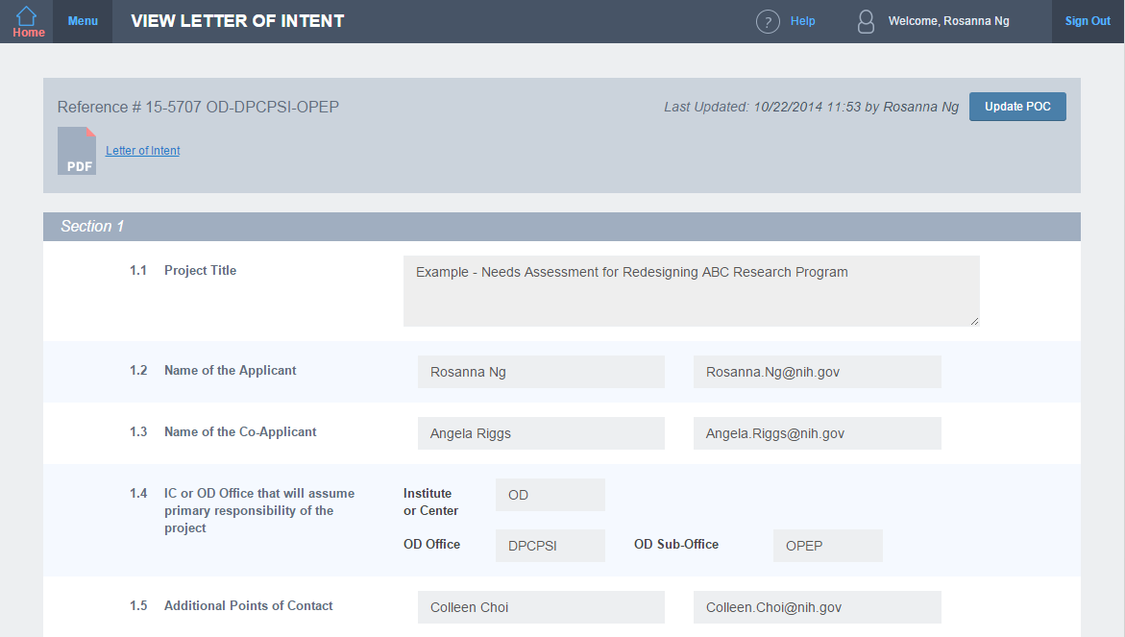
- You can also click on the “PDF” icon or the “Letter of Intent” link in the upper left corner to download a PDF copy.
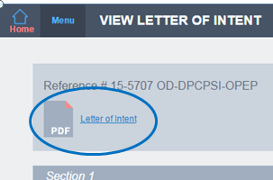
- Return to your homepage by clicking on the “Home” icon. On the homepage, click “Sign Out” to exit the ESA System.

How to Revise LOI to Address Issues Identified by OPEP

- If you receive an email from OPEP asking you to make changes to your LOI by a specified date, you will need to log in to http://esa.od.nih.gov to access the ESA System (see How to Access ESA System on pages 2-3) in order to revise your LOI.
- When your home page is displayed, click “APPLICANT” in the left panel.
- When the menu opens, click on the “Update LOI” link.
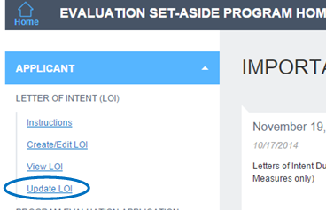

TIPS
- The “Update LOI” link appears only if OPEP has requested changes to your LOI(s). In other words, this link will not appear for applicants whose LOIs do not require revisions.
- When your list of LOI(s) is displayed, click the ESA reference number for the LOI you want to revise.
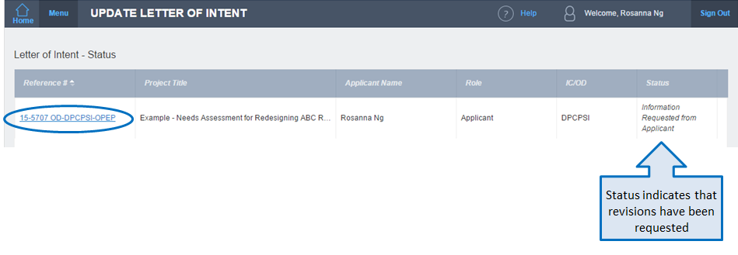
- When the LOI appears, scroll down to the section(s) where changes are needed.
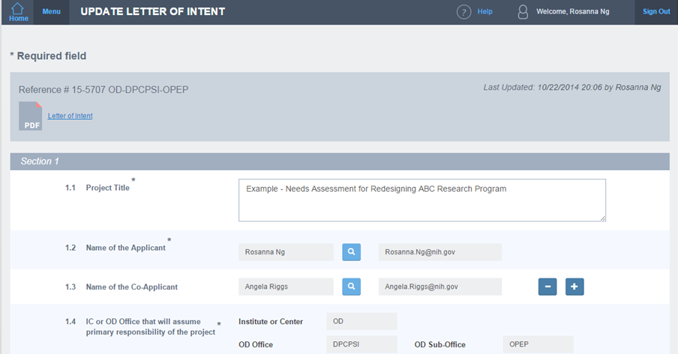
- Edit the appropriate field(s). An example is shown below.
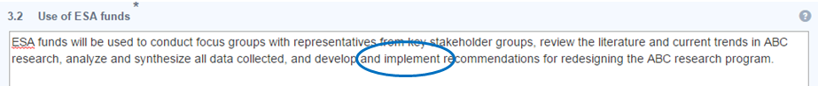

- To review your changes and see how the LOI will appear to reviewers, click “Print Draft LOI” to download a PDF version of your updated LOI.

TIPS
- Review your updated LOI carefully. If you changed certain information in one field, did you also change the corresponding information in another field(s)? Did you accidentally alter a field that you did not intend to change?

- If you are not ready to submit the updated LOI, click “Save as Draft” to save your changes, exit the LOI form, and return to your homepage. 
From your homepage, click “Sign Out” to exit the ESA System.
TIPS
- Set a reminder on your calendar so that you will remember to submit the updated LOI by OPEP’s specified date. You will not receive a reminder from the ESA System or OPEP.
- When you are ready to submit the updated LOI, repeat Steps 1-7 (pages 20-21) as appropriate, then click on the “Submit” button.

- Select “Continue” when a new window appears with the question “Are you sure you want to submit the Letter of Intent?”
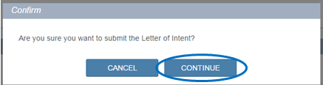
- When your revised submission has been successfully processed, a confirmation page will appear. You will also receive a submission confirmation via email with a PDF copy of your updated LOI attached.
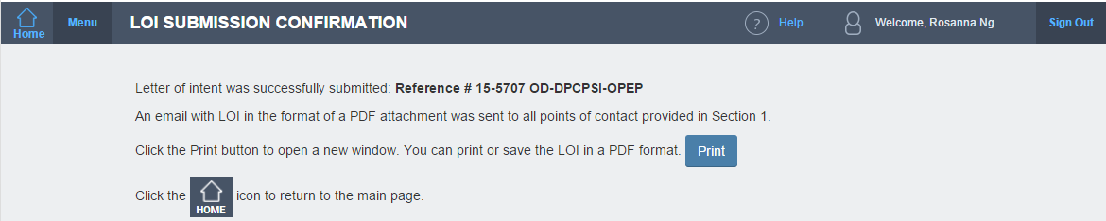
- Return to your homepage by clicking on the “Home” icon, or exit the ESA System by clicking “Sign Out”.

Appendix: Information Needed to Prepare Letter of Intent

FOR REFERENCE ONLY
Letters of Intent must be created and submitted online

Section 1: Project Title and Contact Information

  - Title of proposed project:

1.2 Name and email address of applicant:
List one individual only. This should be a federal employee.

1.3 If applicable, name(s) and email address(es) of co-applicant(s):
Co-applicant(s) will be copied on all correspondence related to the LOI.

1.4 IC or OD Office that will assume primary responsibility for the project:
If OD Office (e.g., OM), include the acronym of the sub-office when applicable (e.g., OHR).

1.5 If applicable, name(s) and email address(es) of additional point(s) of contact:
Include any staff members who should be copied on all correspondence related to the LOI but are not listed elsewhere in this section (e.g., a colleague or P&E staff who worked with the applicant on the LOI).

1.6 Name and email address of the P&E Officer who cleared the LOI for submission:
P&E Officer will be copied on all correspondence related to the LOI.

1.7 If different from applicant (1.2), name and email address of preparer:
Complete this item if the LOI will be created online by someone other than the applicant. The preparer will be copied on all correspondence related to the LOI; it is unnecessary to list him/her under 1.5.

1.8 If applicable, identify any co-sponsor who has agreed to provide financial and/or in-kind support for the project:
If within NIH: indicate the IC or OD Office, and provide the name and email address of the key point of contact.

If outside of NIH: include the organization’s name (e.g., HHS/Office of the Assistant Secretary for Health), and provide the name and email address of the key point of contact.

Contact(s) for co-sponsor(s) will not be copied on any correspondence related to the LOI.

Section 2: Type of Proposed Project

2.1 Type of proposed project (check one):

Program Evaluation
Development of Program Performance Measures

2.2 If the project is a program evaluation, indicate the type of evaluation planned:

 | Needs Assessment |  | Process Evaluation |  | Outcome Evaluation
 | Feasibility Study (to design a process or outcome evaluation)

Section 3: Estimated Cost of Proposed Project

3.1 Estimated cost of the project. Use whole numbers only. The same figure may be used for both lower and upper limits.

Lower Limit: $ |  |  | Upper Limit: $

Reminder: The development of program performance measures may not exceed $100,000 per application.

3.2 Use of ESA funds. Briefly describe (in 3-5 bullet points) how ESA funds will be used to support the project (e.g., survey grant applicants who received funding and those who did not; gather and analyze grantees’ publication data). Note: ESA funds may not be used to develop or implement program activities, including those that stem from findings or recommendations of the proposed project.

Section 4: Program Summary and Project Overview

Note: Section 4 in its entirety may not exceed 10,000 characters.

4.1 Program Summary. Briefly describe the program to be evaluated or for which performance measures will be developed. Include the program’s organizational location within the IC or NIH; the fiscal year it was established; its approximate size in terms of staff and annual budget. Summarize the program’s main goals, functions, and activities. Briefly describe how the program supports the IC or NIH mission – for example, how it advances one or more key IC or NIH priorities, provides cost-savings, enables the IC or NIH to be more efficient or productive, improves transparency and accountability, and/or strengthens the IC or NIH’s ability to comply with legislative, regulatory, or administrative requirements.

4.2 Project Overview. Briefly describe the purpose and scope of the proposed project. Indicate how it will address knowledge gaps about the program described in the Program Summary, how its findings (or products) will be used and by whom, and how the project will support critical and timely decision making by the IC or NIH.

4.3 Trans-NIH Relevance. Briefly discuss how the proposed project and its findings or products may benefit other ICs or NIH at large.

Examples of in-kind support include but are not limited to: assisting with project planning and implementation, and serving on the project’s evaluation advisory committee

